**Exploring props to the Image Component**

In this reading, you will learn about the various props that you can send to the **Image** component to style and customize the images that are being rendered. You will explore the code from an earlier video in detail here. You will update the **Welcome** component to include images.

**Images**

You can download the images for this reading from below and name them Picture1.png, Picture.png, Picture3.png and Picture4.png respectively. Ensure to add these image files to the **img** folder within your project.

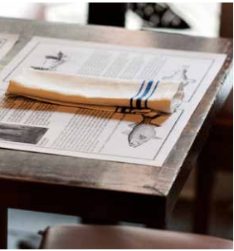

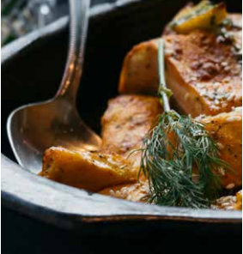



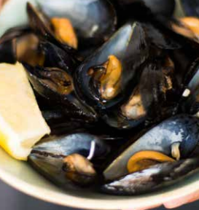

**resizeMode**

The most commonly used prop for the Image component is **resizeMode**. It determines how to resize an image when the window frame does not match the raw image dimensions.

**resizeMode** can accept the following values:

**cover***:* This is used to scale the image uniformly and maintain the image’s aspect ratio. Below is an example of the picture with the menu with **resizeMode** prop set to **cover**.

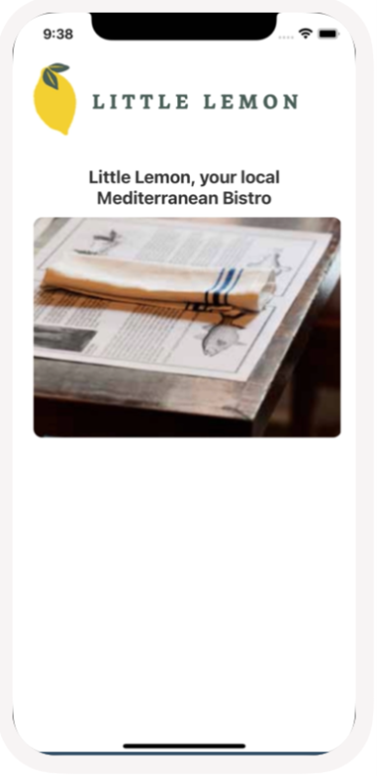

**contain***:* This scales the image uniformly so that both dimensions of the image will be equal to or less than the corresponding dimension of the view.

Below is an example of the picture with the menu with **resizeMode** prop set to **contain**.

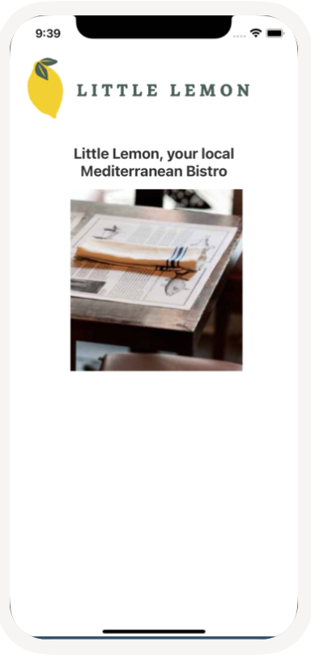

**stretch***:* This is used to scale with height independently and may change the original image's aspect ratio.

Below is an example of the picture with the menu with **resizeMode** prop set to **stretch**.

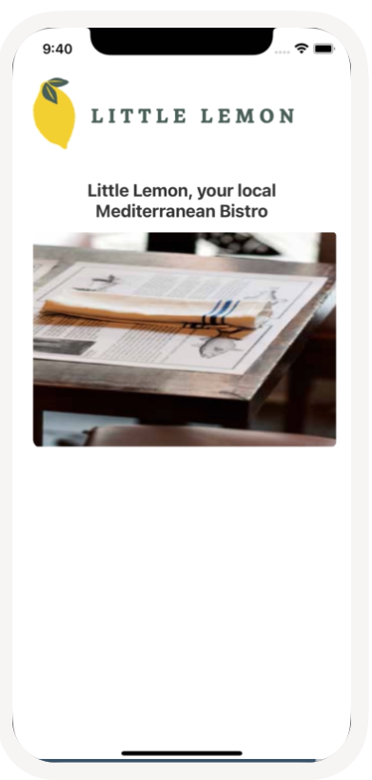

**repeat***:* The image is repeated to cover the frame of the view.

Below is an example of the picture with the menu with **resizeMode** prop set to **repeat**.

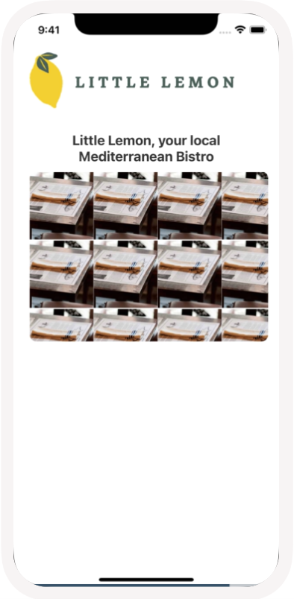

**center***:* The image is centered in the view along with both dimensions.

Below is an example of the picture with the menu with **resizeMode** prop set to **center**.

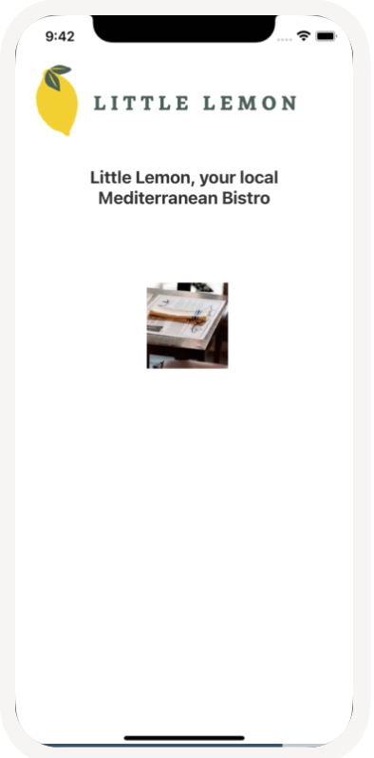

**accessible**

It is always good to keep accessibility as a priority while developing applications. The **accessible** prop accepts a Boolean true or false. When it is set to true, it indicates that the image is an accessibility element.

**accessibilityLabel**

Once the image is set to be accessible, it is time to provide an accessible label for the image. This is the text that the screen reader reads when the user interacts with the image. Make sure to give a meaningful and descriptive name to the prop.

**Putting it all to**

import React from 'react';

import { ScrollView, Image, StyleSheet, Text } from 'react-native';

const Welcome = () => {

  return (

    <ScrollView style={styles.container}>

      <Image

        style={styles.logo}

        source={require('../img/littleLemonLogo.png')}

        resizeMode="center"

        accessible={true}

        accessibilityLabel={'Little Lemon Logo'}

      />

      <Text style={styles.title}>

        Little Lemon, your local Mediterranean Bistro

      </Text>

      <Image

        style={styles.image}

        source={require('../img/Picture1.png')}

        resizeMode="cover"

        accessible={true}

        accessibilityLabel={'Little Lemon Logo'}

      />

      <Image

        style={styles.image}

        source={require('../img/Picture2.png')}

        resizeMode="cover"

        accessible={true}

        accessibilityLabel={'Little Lemon Logo'}

      />

      <Image

        style={styles.image}

        source={require('../img/Picture3.png')}

        resizeMode="cover"

        accessible={true}

        accessibilityLabel={'Little Lemon Logo'}

      />

      <Image

        style={styles.image}

        source={require('../img/Picture4.png')}

        resizeMode="cover"

        accessible={true}

        accessibilityLabel={'Little Lemon Logo'}

      />

    </ScrollView>

  );

};

const styles = StyleSheet.create({

  logo: {

    height: 100,

    width: 300,

  },

  image: {

    width: 350,

    height: 250,

    borderRadius: 10,

  },

  container: {

    flex: 1,

    padding: 24,

    marginTop: 25,

    backgroundColor: '#fff',

  },

  title: {

    marginTop: 16,

    paddingVertical: 10,

    color: '#333333',

    textAlign: 'center',

    fontSize: 20,

    fontWeight: 'bold',

  },

});

export default Welcome;